LAB 7:

Part I:

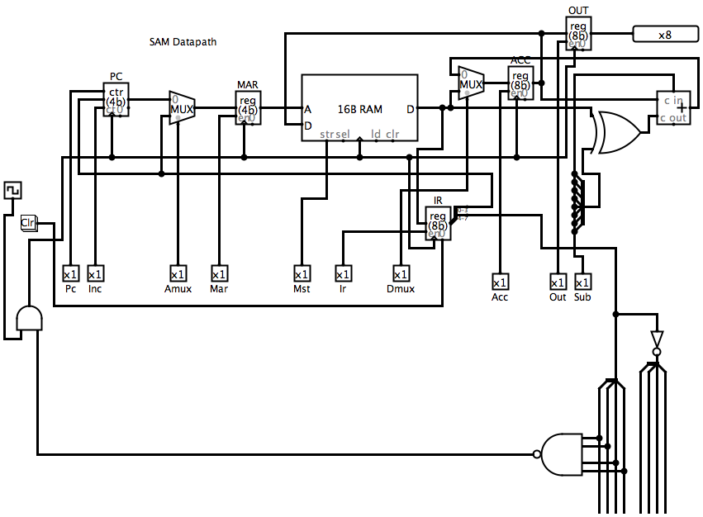

Control Word:

Pc Inc Amux Mar Mst Ir Dmux Acc Out Sub

1x 1x 1x 1x 1x 1x 1x 1x 1x 1x

How many bits? 10 Bits

Part II:

|  |  |  |  |  |  |  |  |  |  |  |
| --- | --- | --- | --- | --- | --- | --- | --- | --- | --- | --- |
| Control Code | | | | | | | |  |  | Action |
| Pc | Inc | Amux | Mar | Mst | Ir | Dmux | Acc | Out | Sub |  |
| 0 | 1 | 0 | 1 | 0 | 0 | 0 | 0 | 0 | 0 |  |
|  |  |  |  |  |  |  |  |  |  |  |